Project Design Phase-II
Technology Stack (Architecture & Stack)
Date | 19 July 2026
Team ID | (Assign as per SmartBridge Portal)
Project Name | Strategic Product Placement & Business Intelligence Suite
Team Members | Vishnu Edara (Team Lead)  Rama Krishna Siripurapu  Sravanthi Nagelli  Liven Tulugu  Jaya Veera Chaitanya Vuyyuru
Maximum Marks | 4 Marks

Technical Architecture
The architectural diagram below reflects the data flow from raw dataset through ETL, BI and web layers, followed by the component and characteristic tables.
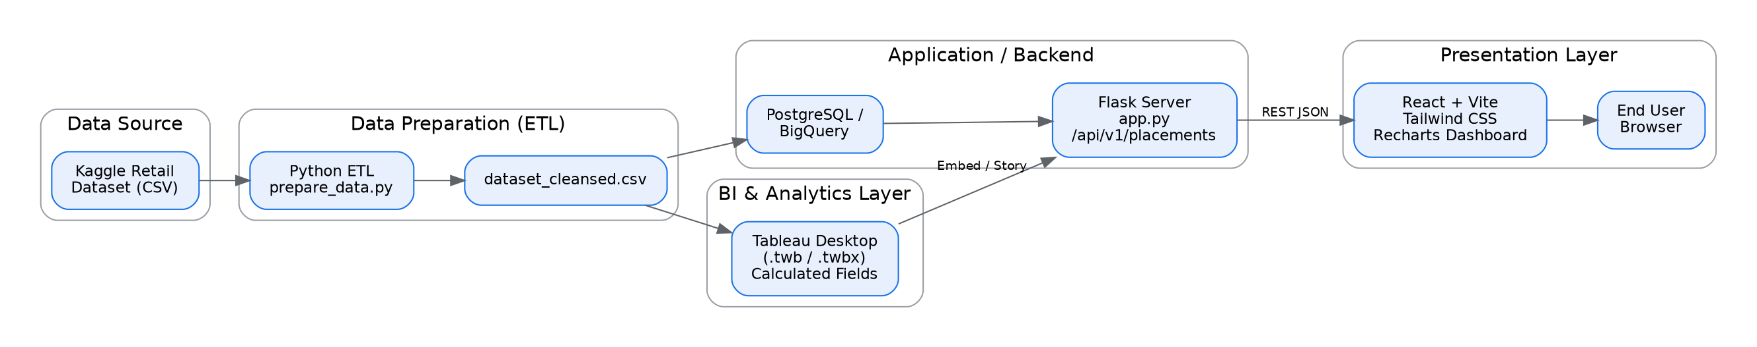

Table-1: Components & Technologies
S.No | Component | Description | Technology
1. | User Interface | How the user interacts with the dashboard (filters, KPI cards, charts) | React 19, Vite, Tailwind CSS, Recharts, Lucide Icons
2. | Application Logic-1 | ETL pipeline: cleaning, imputation, feature engineering | Python (prepare_data.py)
3. | Application Logic-2 | Backend routing and RESTful API exposure | Flask (app.py), Node/Express (server.ts)
4. | Database | Structured storage of product placement records | PostgreSQL
5. | Cloud Database | Data warehouse for large-scale extracts and aggregation | Google BigQuery
6. | File Storage | Raw and cleansed dataset storage | Local filesystem (CSV) / Tableau Packaged Workbook (.twbx)
7. | External API-1 | Embedding published, interactive BI visuals | Tableau Public / Tableau Server Embed API
8. | External API-2 | Authentication and hosting services | Firebase (Auth / Hosting)
9. | AI / ML Model | Generates shelf/planogram optimization recommendations | Google Gemini API (@google/genai)
10. | Infrastructure (Server/Cloud) | Build & deployment pipeline | Vite build + esbuild bundling, deployable to cloud (Node runtime)

Table-2: Application Characteristics
S.No | Characteristics | Description | Technology
1. | Open-Source Frameworks | Core front-end and backend frameworks used across the suite | React, Flask, Tailwind CSS, Recharts
2. | Security Implementations | Credential isolation and safe environment configuration | dotenv-based secrets, Firebase Auth
3. | Scalable Architecture | Clear separation between data, BI, API and presentation layers | 3-tier architecture (ETL -> API -> React UI)
4. | Availability | Stateless services enabling redundancy and quick recovery | Flask REST API, static asset hosting
5. | Performance | Optimized rendering and query response for interactive filtering | useMemo selectors, ResponsiveContainer, <1.8ms filter latency, 60fps

